Sprint 2
Study Buddies Project
CMP-N204-0

- Project Overview
A web-based tool called Study Buddies was created to assist college students in locating compatible classmates for group projects. Students can explore available study requests, post their own requests for academic support, build personalized profiles, and look for study partners based on subjects or categories. The platform seeks to enhance academic engagement, foster peer-to-peer learning, and provide a welcoming learning environment.
A newly developed full-stack architecture comprising Node.js, Express, MySQL, Pug templates, and Docker for containerization will be used to construct the system. GitHub will be utilized for project management, collaboration, and version control. The development method adheres to agile delivery principles, which include user-centred design, iterative development, and ongoing improvement based on feedback. System requirements are analysed and system behaviour is defined using UML modelling approaches.

- User Stories
The needs of the students using the Study Buddies platform are discussed in user stories.
Every story belongs to the format suggested by GOV.UK: As a... I must/wish to Thus, that
The story's completion is determined by acceptance criteria.
- User Story 1: Establish a Profile

I must set up a Study Buddies profile with my topics and personal information as a university student so that other students can get to know me and determine whether I'd be a good study partner.
It's completed when
- When I can enter my name, course, and year, it's finished.
- When I can add subjects that I can assist with, it's finished.
- When I can add subjects that I require assistance with, it's finished.
When my profile is saved and accessible in the system, it's finished.

- User Story 2: Study Buddy List View
I need to see a list of other students who are willing to study because I am a student seeking assistance.
that I can locate possible study partners as soon as possible.
It’s completed when
- When I see a list of students together with their names and subjects, it's finished.
- When I can click on a student to see their entire profile, it's finished.

- User Story 3: Viewing a Student's Profile
Selecting a study companion as a student to determine whether a student is a suitable fit for my needs, I must look at their profile.
It’s completed when
- When I can view their subjects, availability, and bio, it's finished.
- When I can go back to the list after looking at a profile, it's finished.

- User Story 4- Search by Subject

As a student in need of assistance in a particular subject
I have to look for study partners by subject.
in order to locate someone who can assist me with that subject.
It’s completed when
- When I can type or choose a subject, it's finished.
- When the results only display pupils who fit that subject, it is completed.

- User Story 5 – Create a Study Request Listing

As student in need of assistance
I have to make a list of research requests.
so hat other students can offer to learn with me after noticing my areas of need.
It’s completed when
- When I am able to enter a title, subject, and description, it is finished.
- When my listing shows up in the list of research requests, it's finished.
- View Study Request Details

As students who want to assist
I must see a study request's specifics.
so that I can determine if I can provide assistance
It’s completed when
- When I see the complete description, the subject, and the person who posted it
- User Story 7 – Browse by Category/Tags

As the student looking into possibilities
I have to look through study requests and study companions by tags or categories.
so that even if I don't have a certain person in mind, I can find sessions and people who are relevant.
It’s completed when
- When I can click on a category or tag, it's finished.
- When I come across matching profiles or listings, I take action.

- User Story 8 – Send a message

Setting up a study session as a student, I have to message a different student so that we may coordinate when and how to learn together and communicate.
It’s completed when
- When I am able to access a message interface from a student's profile or study request, it is finished.
- When I can type and send a message, it's finished.
- When the other student receives and can see the message, it is completed.
- When I can see the messages I've already sent, it's finished.

- Use Case Diagram

Based on the user stories established in part 2, this part outlines the primary players and use cases for the Study Buddies system. A high-level overview of how a student uses the system and what features it needs to have is given by the use case diagram.

- Actors

Student: A college student who makes use of the Study Buddies system in order to:
- Establish and maintain their profile
- Look for and peruse other pupils
- Send messages to other students to set up study sessions
- create and view study requests; and (optionally)

The student is currently the top major actor considered by the system. If necessary, other actors (such as an administrator or moderator) might be added in subsequent stages.

- Use Cases

The Study Buddies system's primary use cases are:
- Create Profile
The student makes a personal profile that includes their name, course, year, and any subjects they need or can help with.

- View List of Study Buddies
A list of other students who are willing to study or provide assistance is displayed to the student.

- View Student Profile
The student looks at another student's complete profile, which includes their availability and subjects.

- Search by Subject
The student looks for study partners based on a certain topic or discipline.

- Browse by Category/ Tags
Through the use of categories or tags, such as "Maths," "Programming," or "First year," the student looks through study partners or requests.

- Create Study Requests
The student makes a list of study requests, outlining the topic and areas in which they require assistance.

- View Study Request Details
A particular study request made by another student can be seen in its whole by the student.

- Send Message
To communicate and plan a study session, the student messages another student.

- Use Case Relationships

The following are the connections between the actor and use cases as well as between use cases:
- Since they are the system's main user, the student actor is connected to each of the mentioned use cases.
- View List of Study Buddies is a key use case that:
    - Create Study Request is used by students to create study requests.
    - The whole details of those requests are then visible to other students by using View Study Request Details.

- Send message can be started from:
    - After looking at another student's profile, the student chooses to get in touch with them.
    - The student makes the decision to get in touch with the person who created the study request.

- System Boundary

The "Study Buddies System" border includes all of the aforementioned use cases. Through the specified use cases, the Student actor, who is external to the system, communicates with it.

In the use case diagram:
- The "Study Buddies System" rectangle serves as a representation of the system border.
- Every use case (oval) is illustrated within this rectangle.
- The student actor (stick figure) is shown outside the rectangle, and association lines are used to link it to the appropriate use cases.

- Use Case Diagram

Figure 1: Use case diagram for the Study Buddies System.
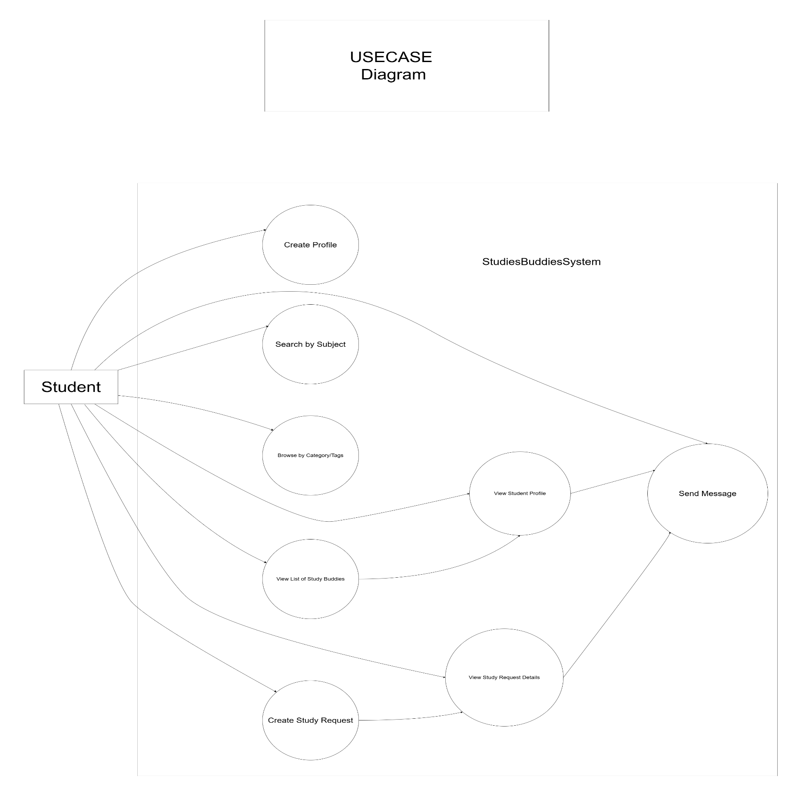

- Sprint 2 Specification

The Study Buddies platform's system requirements were gathered and improved during Sprint 2. Before development started in Sprint 3, the goal of this sprint was to make sure that all functional expectations, user requirements, and system behaviours were well defined. The core documentation needed for planning, modelling, and interface design was created during this sprint.

- Objectives of Sprint 2
Sprint 2 aimed to :
- Improve the Study Buddies project concept in context of Sprint 1 input.
- Use organized user stories to determine and record user needs.
- Using a use case diagram, specify the functional scope of the system.
- Determine the main actor and system boundary.
- Create first wireframes to illustrate the system's main pages.
- Start using activity diagrams to model the behaviour of the system.
- Make sure every specification is prepared for development in Sprint 3.

The implementation work scheduled for Sprint 3 is built upon these deliverables.

4.2 Wireframes

A simple visual depiction of the Study Buddies system's primary pages is offered by wireframes. They prioritize usefulness and layout over aesthetics. The use cases and user stories described in previous sections served as the foundation for the wireframes.
The following key pages are represented:
- Home/Landing Page
The Study Buddies system is introduced on the home page, which also offers easy access to its key features.

Key Elements:
- Header with logo and site name (“Study Buddies”)
- Navigation links (e.g. Home, Study Buddies, Study Requests, Login/Profile)
- Introductory text explaining the purpose of the platform
- Call to action buttons(e.g. “View Study Buddies”, “View Study Requests”)
- Footer with basic information (e.g. contact, copyright)

Figure: Wireframe- Home Page Wireframe
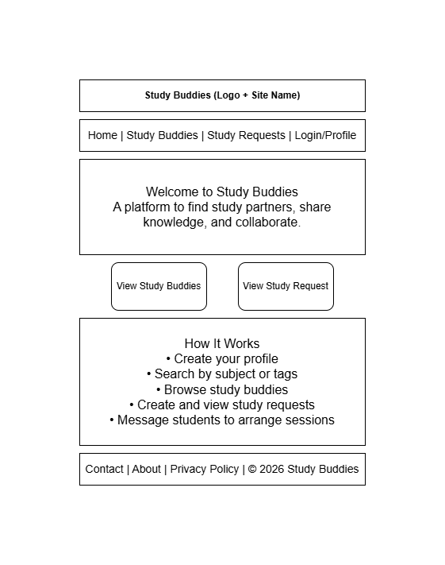

- Users List Page (Study Buddies List)
This page shows a list of students who are available to study or offer help.

Key elements:
- Page title (e.g. “Find a Study Buddy”)
- Search bar to search by subject or keyword
- Filter options or tags (e.g. subject, year, course)
- List of student cards, each showing:
- Student name
- Course / year
- Key subjects
- “View Profile” button or link
- Pagination or “Load more” if needed

Figure : Wireframe – Users list page
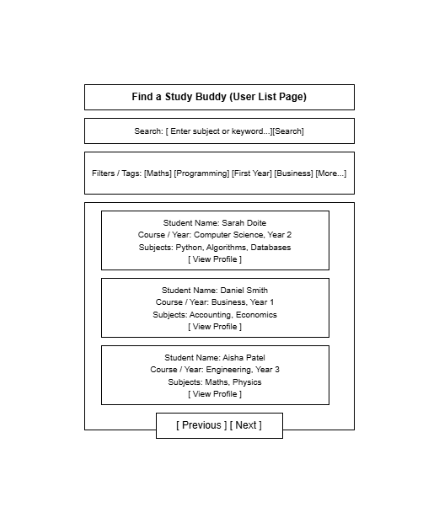

- Student Profile Page
This page shows detailed information about a specific student.
Key elements:
- Student name and basic details (course, year)
- Short bio or description
- Subjects they can help with
- Subjects they need help with
- Availability information (e.g. evenings, weekends)
- Button or link to “Send Message” (optional, for future sprint)
- Back link to return to the Users List page

Figure : Wireframe – Student profile page
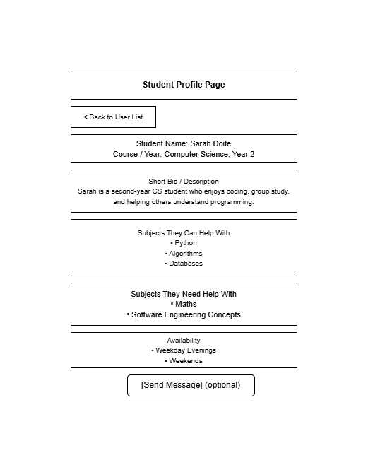
- Study Request List Page
This page shows a list of study requests created by students.
Key elements:
- Page title (e.g. “Study Requests”)
- Button to “Create Study Request”
- Filter or tag options (e.g. subject, level)
- List of request cards, each showing:
- Request title
- Subject - Short description or snippet
- Name of the student who created it
- “View Details” button or link

Figure : Wireframe – Study request list page
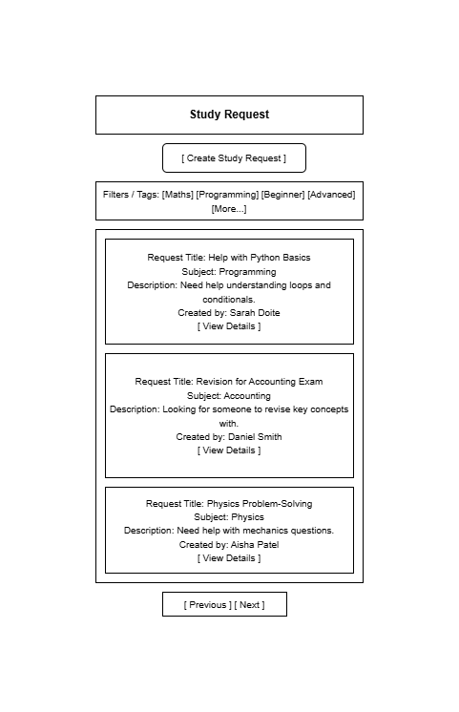

- Study Request Detail Page
This page shows the full details of a specific study request.
Key elements:
- Request title
- Subject and tags
- Full description of the help needed
- Name and basic details of the student who created the request
- Optional: “Send Message” button to contact the student
- Back link to return to the Study Request List page

Figure : Wireframe – Study request detail page
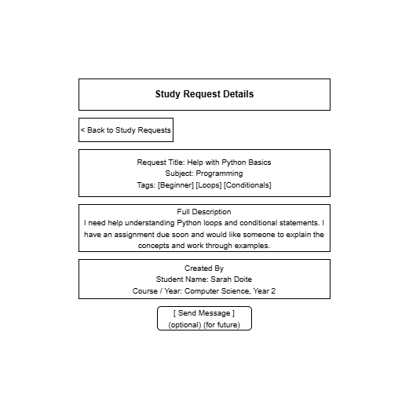

  - Activity Diagrams
Activity diagrams show how important user interactions proceed. These schematics aid in describing system behaviour and directing Sprint 3 implementation.

- Activity Diagram – Search for Study Buddies
Steps:
- Student opens the Study Buddies List page
- Student enters a subject or selects a tag
- System retrieves matching profiles
- System filters results
- System displays filtered list
- Student selects a profile
- System loads the profile page.

Figure : Activity Diagram – Search for Study Buddies
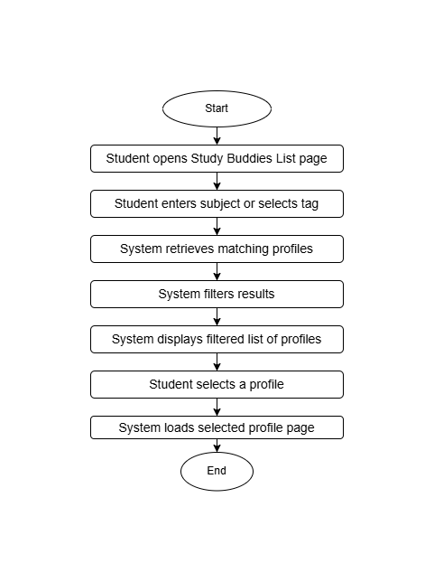

- Activity Diagram – Create Study Request
Steps:
- Student opens the Create Study Request page
- Student enters title, subject, and description
- Student submits the form
- System validates input
- If invalid → show errors
- If valid → save to database
- System confirms creation
- Updated list of study requests is displayed

Figure : Activity Diagram – Create Study Request
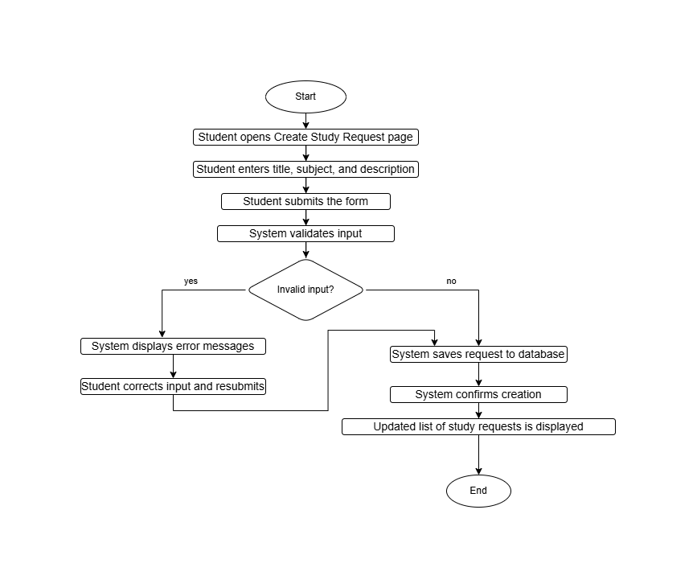
- Activity Diagram – View Study Request Details
Steps:
- Student opens Study Request list page
- Student selects a request
- System retrieves request details
- System retrieves creator details
- System displays full request information

Figure : Activity Diagram – View Study Request Details
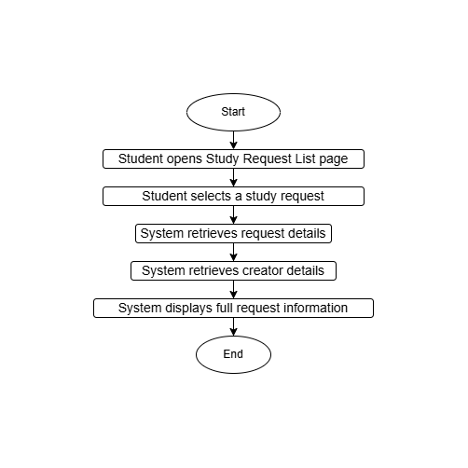

  - Optional Artefacts
The Sprint 3 definition is strengthened and deeper planning is demonstrated by optional artefacts.
- Entity Relationships Diagram (ERD)
Entities:
- Student : represents every system user.
- Subject : Classes like programming, math, etc.
- Student_Subject : connection table that connects subjects and students.
- Study_Request : a request made by a student seeking assistance.
- Message (future sprint) : Student to student communication (future sprint).

- Relationships:
- Student ↔ Subject = Many-to-Many
Implemented using Student_Subject
- Student → Study_Request = One-to-Many
A student can create many study requests.
- Student ↔ Student (via message) = Many-to-Many
Implemented using Message table( sender_id, receiver_id)
- Student → Study_Request = Optional
Stored as text .

ERD diagram
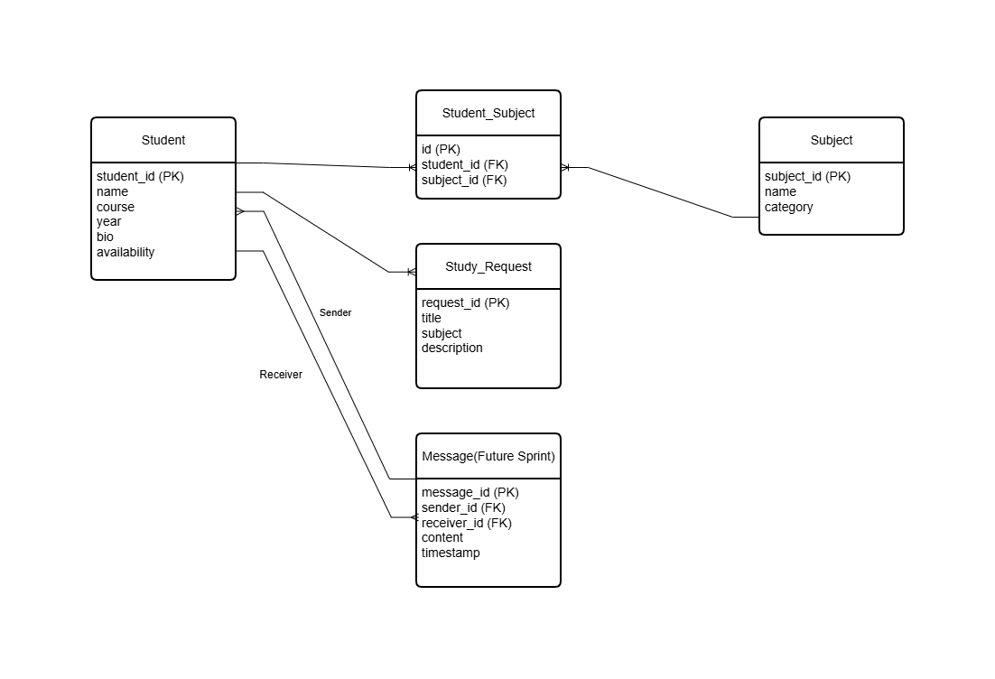
- Sequence Diagram – View Student Profile
Flow:
- Student selects profile
- System retrieves student data
- System retrieves subjects
- System renders Pug template
- Profile page displays

Sequence diagram – View Student Profile
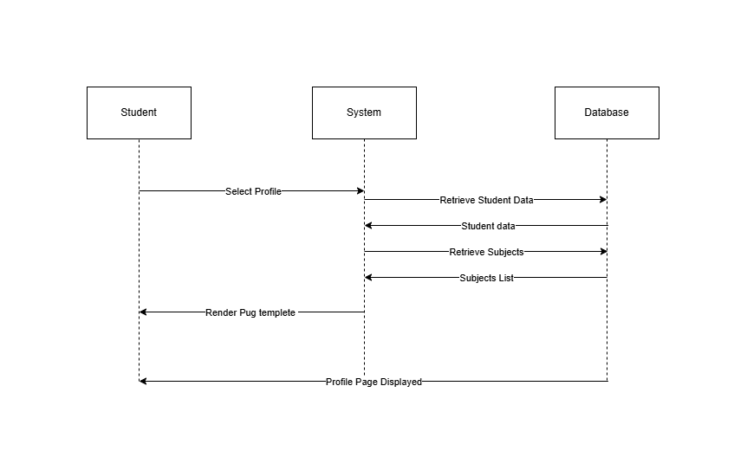

- Sequence Diagram – Create Study Request
Flow:
- Student opens form
- Student submits details
- System validates
- System saves to database
- System confirms creation

Sequence diagram – Create Study Request
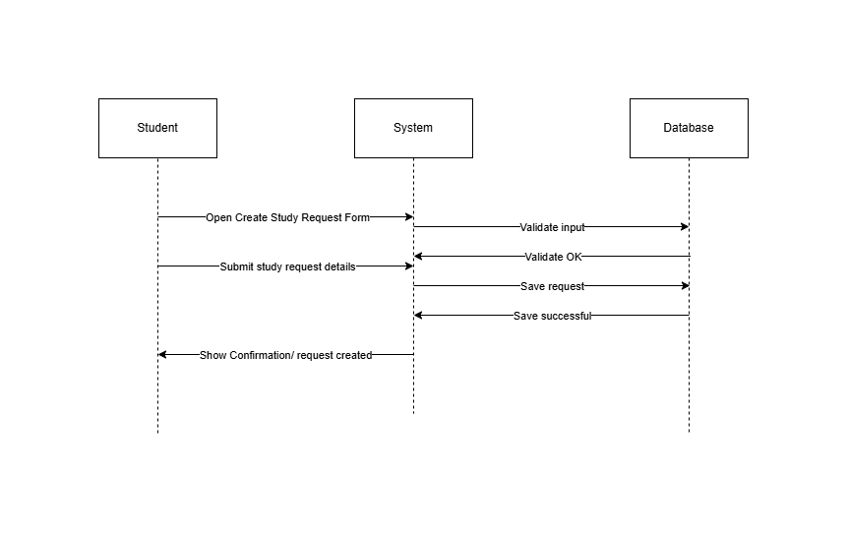

- Kanban Board Screenshot
Tasks for Sprints 2 is managed using the GitHub Project Kanban board.
The board includes the following columns:
- Backlog – all tasks not yet started
- Sprint 2 – Documents tasks(user stories, diagrams, wireframes)
- In progress
- Done – Completed tasks

Insert ss of your kanban board

- GitHub Repository Link
GitHub is used by the Study Buddies project for project management, version control, and teamwork.

GitHub Repository link here https://github.com/kiranbhusalusha-bit/study-buddies
The repository includes:
- Scaffolding files
- README customised for the project
- Contributions from all team members
- Link to the GitHub Project Kanban board used to manage Sprint 2 tasks
- Upload diagrams(wireframes, activity diagrams, sequence diagrams, ERD)

- Meeting Records

Meeting records document team collaboration and progress throughout the sprint.

Meeting Record 1 – Sprint 2 Planning
Date and time: 12 February 2026, 18:00
Project Name: Study Buddies
Meeting Goal: Plan Sprint 2 and allocate documentation tasks
Facilitator: Usha
Note taker: Prasansa
Attendees: Usha, Nirja, Prasansa
Roundtable Updates:
- Usha : reviewed the feedback from Sprint 1 identifying any lacking documentation.
- Niraj : Verified preparation to enable backend-related planning and ERD.
- Prasansa : Ready to help with UI-related artifacts and wireframes.

Discussion Points:
- Clarified Sprint 2 deliverables with lecturer comments.
- Verified the configuration of the Kanban board and GitHub repository.
- Talked about the platform's personalities and ethical issues.
- User stories, use case diagrams, wireframes, activity diagrams, and sequence diagrams were all agreed upon as documentation tasks.
- Made plans for the final Sprint 2 submission.

Actions:
- Usha: Create sequence diagrams, acceptance criteria, and user stories.
- Niraj: Assist with database-related planning and ERD construction.
- Prasansa: Make and improve wireframes.
- All: Update Kanban board with assigned tasks.

Meeting Record 2 – Mid Sprint Review
Date and time: 19 February 2026, 13:00
Project Name: Study Buddies
Meeting Goal: Examine the status and make sure the Sprint 2 artifacts are on schedule.
Facilitator : Usha Bhusal
Note taker: Niraj
Attendees: Usha, Niraj
Roundtable Updates:
- Usha: User stories and acceptance criteria have been finished, and activity and sequence diagrams are being worked on.
- Niraj: ERD draft finished; entities and relationships verified.

Discussion Points:
- Examine Sprint 1 professor input to make sure the necessary adjustments were made.
- Figure numbering, captions, and document formatting were determined to constitute extra responsibilities.
- The features (messaging, search, and profile editing) that will be prioritized .
- assigned accountability for the leftover artifacts from Sprint 2.
- The group decided how and when to review the diagrams before submitting them.

Actions:
- Usha : Complete the sequence and activity diagrams.
- Niraj : Complete the ERD and verify the schema.
- Prasansa(absent but assigned): Verify UI consistency and enhance wireframes.
- All : Examine GitHub artifacts prior to final submission.

Meeting Record 3 – Sprint 2 Wrap – UP

Date and time: 26 February 2026, 16:00
Project Name: Study Buddies
Meeting Goal: Finalize Sprint 2 deliverables and get ready to submit
Facilitator: Usha
Note taker: Prasansa
Attendees: Usha, Niraj, Prasansa
Roundtable Updates:
- Usha: Diagrams and documentation are finished, and the final report may be assembled.
- Niraj: Backend planning tasks have been added to the backlog after ERD validation.
- Prasansa : Wireframes were enhanced and matched user stories.

Discussion Points:
- examined every artifact from Sprint 2, including use case diagrams, wireframes, activity diagrams, sequence diagrams, ERD, and user stories.
- verified that the documentation and diagrams were consistent.
- Ensured that all files are updated in the GitHub repository.
- Verified that the Kanban board is prepared for a screenshot.
- Next actions for Sprint 3 implementation were discussed.

Actions:
- Usha : Create the final Sprint 2 document and submit it to GitHub.
- Niraj: Add Sprint 3's backend tasks to the Kanban board.
- Prasansa : Wireframes and UI components are finalized.
- All : Confirm final submission approval

